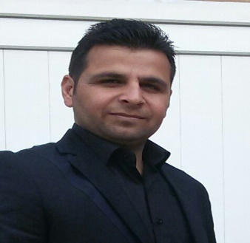

**Saad Shekho Hussein**

**Maintenance engineer**

**Phone : +9647511639213**

**E-mail : [saad19871987.sss@gmail.com](mailto:saad19871987.sss@gmail.com)**

**PERSONAL INFORMATION**

Date of Birth : 14 – 10 – 1987

Place of Birth : wana

Gender : Male

Marital status : married

Driving : Yes, valid driving license issued by the traffic directorate of mosul

Nationality : Iraqi

**EDUCATION BACKGROUND**

* **From university of mosul I got in 2010 on diploma technician**

**Electrical technologies department .**

**OVERVIEW :**

At the beginning of my study examined the basics of equipment of electrical and

how it work and how to generate the ability of electric and studied too brief for

transmission lines of electrical and adapters electrical .

studied also most important programs computer( excel, word) .

* **From university of mosul I got in 2013 on baclorus technical college Department of electrical power engineering technical .**

**OVERVIEW :**

After we got a certificate diploma completed my studies in the college of technical

Department of engineering techniques the ability of electrical dealt with my studies

how to generate the ability of electrical and how maintenance electric motors and

mechanical and method wrap electric motor .

studied also how it works diesel engine and how to maintain and I learned also how

to power transmission of –born consumer by converted lever and another flat .

studied also on programs computer (word , excel , …..etc )

EXPERIENCE

* After I got my certificate diploma entered the cycle a training in the mosul dam and

Worked in the maintenance of water pumps .

* After I got my certificate baclorus entered in the course a training in the mosul dam

to check units main power generation how to run and the way maintenance .

* I work as an employee (contract) in the in dependent high electoral commission as

in put date to a compute .

• I worked in the company of ster group .

OVERVIEW :

- I was responsible maintenance for all billdings in the site .

- I was responsible for the Operation electric generator and maintenance .

- I was responsible for the installation and maintenance of air conditioners(AC).

**THER SKILLSO**

* Good work on the computer .
* I have the experience of action three years in the field of electrical .

**Language**

|  |  |  |  |
| --- | --- | --- | --- |
| **Language** | **Reading** | **Speaking** | **Writing** |
| Arabic | Excellent | Excellent | Excellent |
| English | Good | Good | Good |
| Kurdish | Good | Very good | Good |